**Error & Solutions**

1. INVALID_ACCOUNT_ID

error_code: 'INVALID_ACCOUNT_ID',

error_message: 'account_id specified does not belong to a depository account',

**Solutions**

<https://plaid.com/docs/errors/invalid-input/#common-causes-3>

1. INVALID_ACCOUNT_ID

error_code: 'PRODUCTS_NOT_SUPPORTED',

error_message: **:** 'the following products are not supported by this institution: ["auth"]',

error_type: 'ITEM_ERROR',

**Solutions**

[https://plaid.com/docs/errors/item/#products_not_supported](https://plaid.com/docs/errors/item/%23products_not_supported)

**#) We can’t get processor Token.**

1)

{

"country_codes": [

"US"

],

"institution_id": "ins_130347",

"name": "Chiphone Credit Union",

"oauth": false,

"products": [

"assets",

"balance",

"transactions"

],

"routing_numbers": []

}

Types of Accounts and there Error

data: {

display_message: null,

documentation_url: 'https://plaid.com/docs/?ref=error#item-errors',

error_code: 'PRODUCTS_NOT_SUPPORTED',

error_message: 'the following products are not supported by this institution: ["auth"]',

error_type: 'ITEM_ERROR',

request_id: 'GdKFfKGdAeGvYP3',

suggested_action: null

}

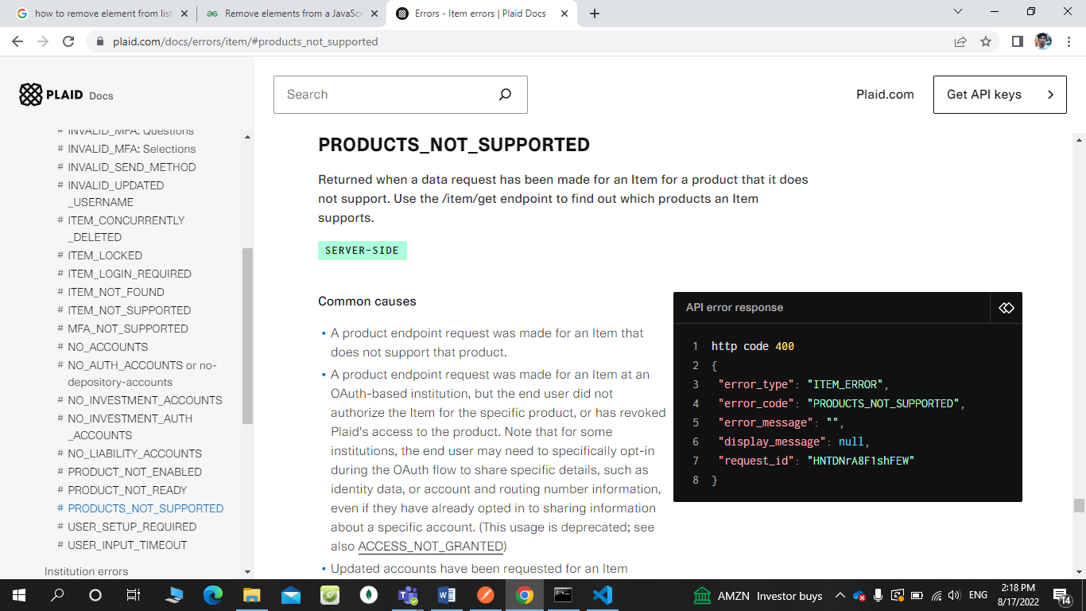

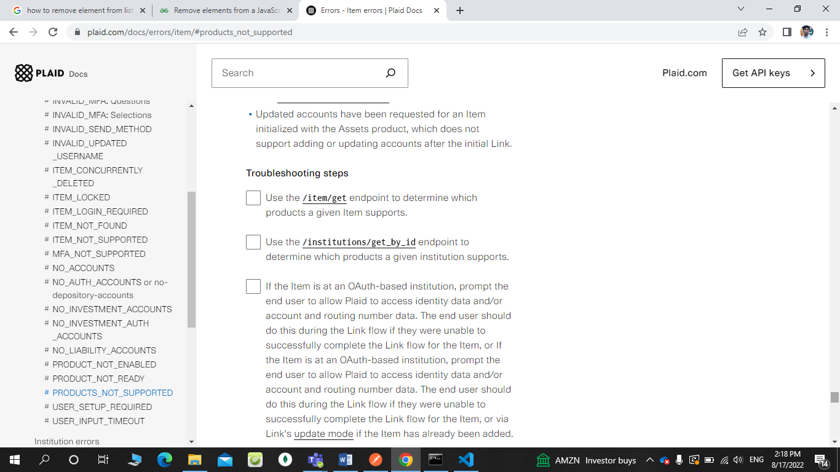

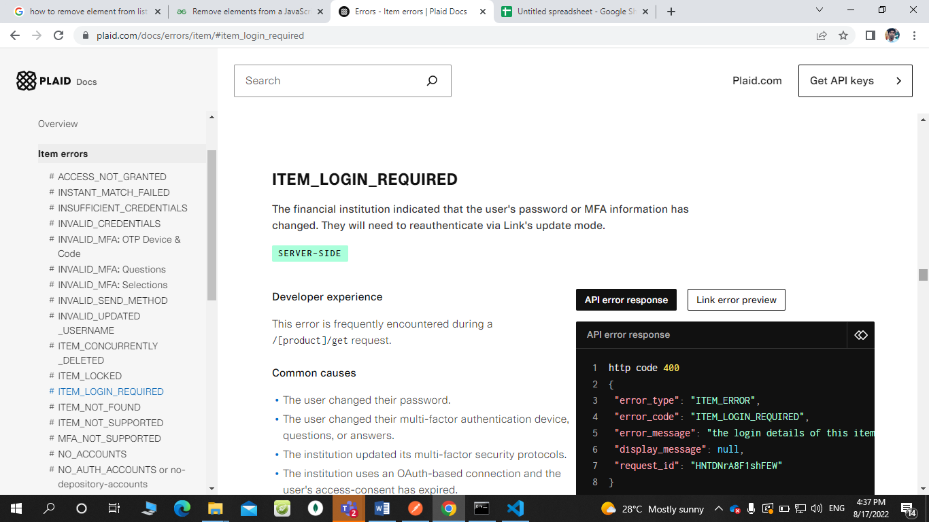

2)

#){

"country_codes": [

"US"

],

"institution_id": "ins_116960",

"name": "M1 Finance",

"oauth": false,

"products": [

"assets",

"balance",

"transactions",

"income",

"identity",

"investments"

],

"routing_numbers": []

}

#) **We get processor Token.**

1)

{

"country_codes": [

"US"

],

"institution_id": "ins_129418",

"name": "Found",

"oauth": false,

"products": [

"assets",

"auth",

"balance",

"transactions",

"identity"

],

"routing_numbers": [

"011401533",

"026015053",

"121145307",

"211075086"

]

}

2)

{

"country_codes": [

"US"

],

"institution_id": "ins_127892",

"name": "GO2bank",

"oauth": false,

"products": [

"assets",

"auth",

"balance",

"transactions",

"deposit_switch",

"identity"

],

"routing_numbers": [

"011401533",

"026009593",

"056073502",

"124303162",

"125008547",

"221571415",

"256074974",

"323691374",

"497266952"

]

}

**#) We get processor Token.**

1)

{

"country_codes": [

"US"

],

"institution_id": "ins_131515",

"name": "Garden FI Bank",

"oauth": false,

"products": [

"assets",

"auth",

"balance",

"transactions",

"identity"

],

"routing_numbers": []

}

2)

{

"country_codes": [

"US"

],

"institution_id": "ins_130973",

"name": "Hancock Whitney",

"oauth": false,

"products": [

"auth",

"balance",

"transactions",

"identity"

],

"routing_numbers": []

},

**#) We get processor Token.**

1)

{

"country_codes": [

"US"

],

"institution_id": "ins_130209",

"name": "5th Bank of Eastern Fargo",

"oauth": true,

"products": [

"assets",

"auth",

"balance",

"transactions",

"identity",

"investments",

"liabilities"

],

"routing_numbers": []

},

2)

{

"country_codes": [

"US"

],

"institution_id": "ins_127329",

"name": "Twentieth National Farmer's Credit Union",

"oauth": true,

"products": [

"assets",

"auth",

"balance",

"transactions",

"identity"

],

"routing_numbers": []

},

**#)We can’t get public token.**

**error_code: 'INTERNAL_SERVER_ERROR',**

**error_message: 'an unexpected error occurred'**

1)

{

"country_codes": [

"US"

],

"institution_id": "ins_127990",

"name": "U.S. Bank",

"oauth": true,

"products": [

"assets",

"auth",

"balance",

"transactions",

"credit_details",

"income",

"identity",

"investments",

"liabilities"

],

"routing_numbers": [

"041202582",

"042000013",

"042100175",

"064000059",

"121122676",

"121201694",

"307070115"

]

}

2)

{

"country_codes": [

"US"

],

"institution_id": "ins_131968",

"name": "AngelList Stack",

"oauth": true,

"products": [

"assets",

"auth",

"balance",

"transactions",

"identity"

],

"routing_numbers": [

"011401533",

"051402372"

]

},

3)

**error_code: 'ITEM_LOGIN_REQUIRED',**

**error_message: "the login details of this item have changed (credentials, MFA, or required user action) and a user login is required to update this information. use Link's update mode to restore the item to a good state"**

{

"country_codes": [

"US"

],

"institution_id": "ins_131957",

"name": "Benepass",

"oauth": true,

"products": [

"assets",

"auth",

"balance",

"transactions",

"identity"

],

"routing_numbers": [

"051409702"

]

},

**#) We get processor Token.**

1)

{

"country_codes": [

"US"

],

"institution_id": "ins_131862",

"name": "A+ Federal Credit Union",

"oauth": true,

"products": [

"assets",

"auth",

"balance",

"transactions",

"identity",

"investments",

"liabilities"

],

"routing_numbers": [

"011401533",

"314977104"

]

}

2)

{

"country_codes": [

"US"

],

"institution_id": "ins_132254",

"name": "Citizens Bank (Amersterdam, MO)",

"oauth": true,

"products": [

"assets",

"auth",

"balance",.

"transactions",

"identity"

],

"routing_numbers": [

"011401533",

"101217514",

"211186522"

]

}

**#) We can’t get Processor Token**

1)

error_code: 'ITEM_LOGIN_REQUIRED',

error_message: "the login details of this item have changed (credentials, MFA, or required user action) and a user login is required to update this information. use Link's update mode to restore the item to a good state",

error_type: 'ITEM_ERROR',

{

"country_codes": [

"US"

],.

"institution_id": "ins_132201",

"name": "Fundomate",

"oauth": true,

"products": [

"assets",

"auth",

"balance",

"transactions",

"identity"

],

"routing_numbers": []

},